. **Oxidation number/OXIDATION STATE**

**It is the charge exhibited by an ion when it is formed from its neutral atom either by gain or loss of electrons (Oxidation or reduction)**

**Oxidation-loss of electron**

**Reduction-gain of electron**

**For example: M0(neutral atom) M+1 + e- (loss) oxidation**

**Reduction M0(neutral atom) + e-  M-1 (gain)**

**Oxidation state-Valency of the atom**

* ***Oxidation number****, also called****oxidation state***, the total number of [electrons](https://www.britannica.com/science/electron) that an [atom](https://www.britannica.com/science/atom) either gains or loses in order to form a [chemical bond](https://www.britannica.com/science/chemical-bonding) with another atom.
* Each atom that participates in an [oxidation-reduction reaction](https://www.britannica.com/science/oxidation-reduction-reaction) is assigned an oxidation number that reflects its ability to acquire, donate, or share electrons.
* The [iron](https://www.britannica.com/science/iron-chemical-element) ion Fe**3+,** for example, has an oxidation number of +3 because it can acquire three electrons to form a chemical bond,
* while the [oxygen](https://www.britannica.com/science/oxygen) ion O2− has an oxidation number of −2 because it can donate two electrons. In an electronically neutral substance, the sum of the oxidation numbers is zero; for example, in [hematite](https://www.britannica.com/science/hematite) (Fe2O3) the oxidation number of the two iron atoms (+6 in total) balances the oxidation number of the three oxygen atoms (−6).

QUESTION CALCULATE THE OS OF SULPHUR IN H2SO4

2+X-8=0 x=+6

[C2O4 ]2-

2X-8=-2 X=+3

1.Calculate oxidation state of K in KMnO4 and K2Cr2O7

2. OXIDATION STATE OF Fe In

[Fe(CN)6]3-

**For s block-** their group number is their oxidation number for H group number is 1 it can combine with metals or non metals (-1 and +1)

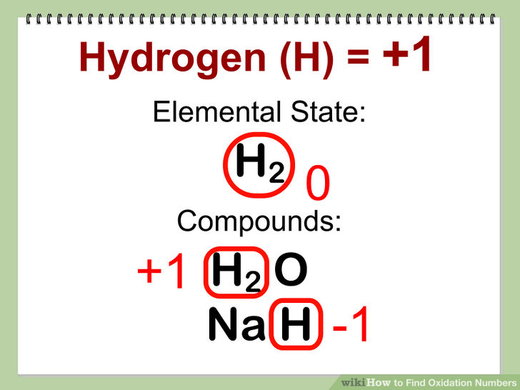

H2O= 2x-2=0 x=+1

NaH= x+1 =0 x=-1

**For p block-** number of valence electrons minus 8 represents its oxidation state (V-8) example chlorine (2,8,7) so 7-8=-1 hence oxidation state is -1 on chlorine

**For d block-** **Highest Oxidation State for a Transition metal = Number of Unpaired d-electrons + Two s-orbital electrons**

**For example iron 26 OS is 4+2= +6**

Indeed, +6 is one of the oxidation states of iron, but it is very rare. Other possible oxidation states for iron includes: +5, +4, +3, and +2.

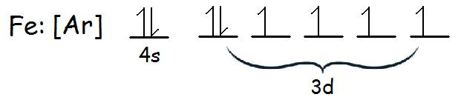

**For F block-** the dominant **oxidation state** of these elements is +3 (similar to lanthanides). Besides +3 **state**, they also exhibit +4 **oxidation state**.

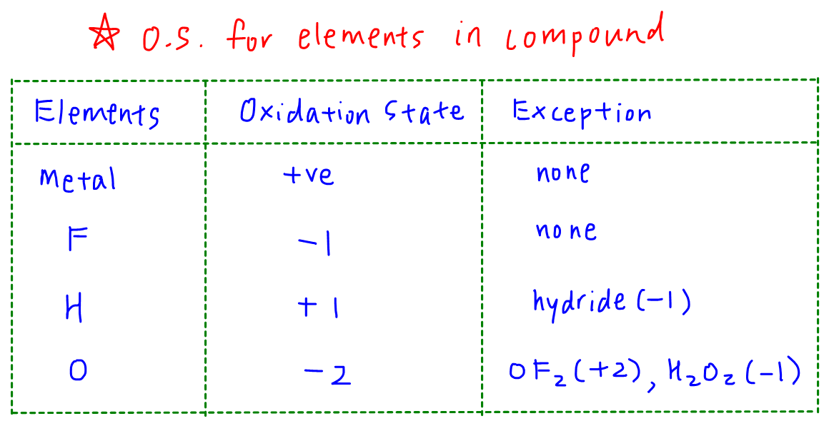

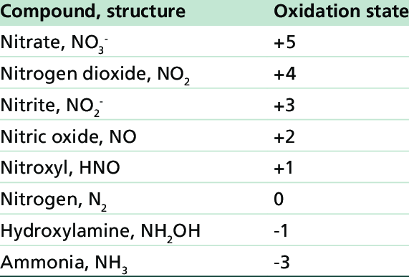

**Coordination number**

* The total number of points (ligands) attached to the central element is termed the **coordination number** and this can vary from 2 to as many as 16, but is usually 6.
* In simple terms, the coordination number of a complex is influenced by the relative sizes of the metal ion and the ligands and by electronic factors, such as charge which is dependent on the electronic configuration of the metal ion.
* Ligands are the point charges which can be negative or neutral are pointing towards the metal cation.

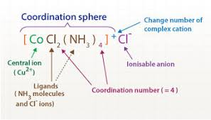

**UNIDENTATE LIGANDS: WHICH ARE HAVING ONLY ONE BONDING SITE.**

Bidentate ligand N::Oxlate ion C2O42-  is having two bonding sites

COO-

COO-

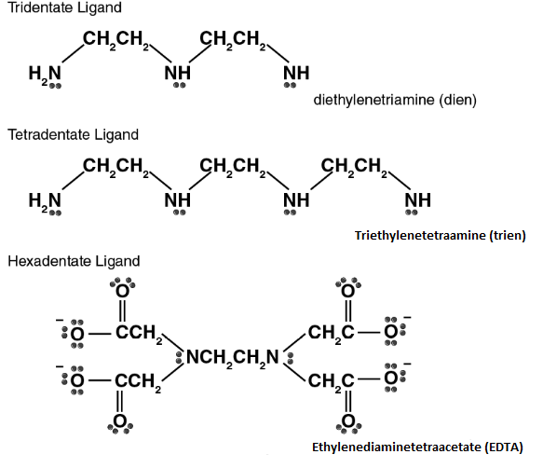

-

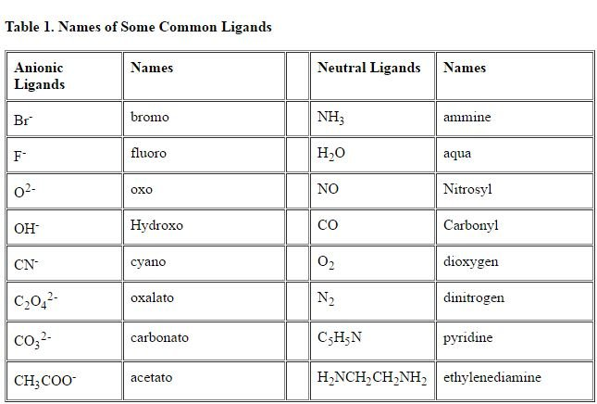

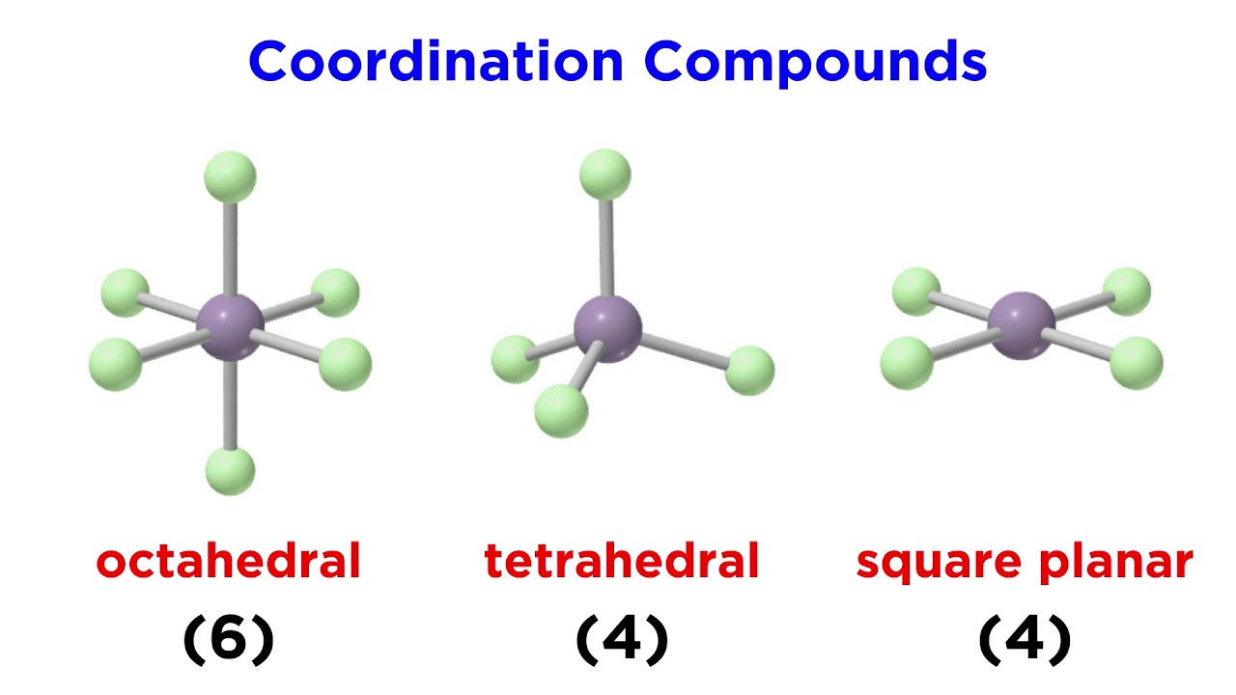

|  |  |
| --- | --- |
| **Coordination Number** | Geometry |
| 2 | **Linear** |
| 3 | **Trigonal planar Geometry** |
| 4 | **Tetrahedral Geometry,Square Planar Geometry** |
| 5 | * **Square pyramid Geometry** * **TrigonalBipyramid Geometry** |
| 6 | * **Hexagonal planar Geometry**: * **Trigonal prism Geometry** * **Octahedral (Oh)** |

